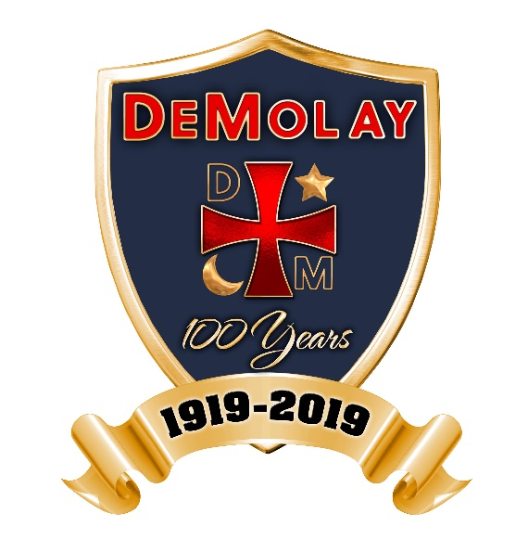

DeMolay Month Proclamation Template

WHEREAS, the Order of DeMolay is a character building organization of young men from twelve to twenty-one years of age; and
WHEREAS, under the mentorship of adults, these young men are taught to prepare themselves to become better citizens and leaders for tomorrow through the use of a variety of self-directed, real world applications and activities; and
WHEREAS, the philosophies of DeMolay are centered on the seven cardinal virtues of filial love, reverence, courtesy, comradeship, fidelity, cleanness and patriotism;
WHEREAS, DeMolay helps develop young men of character into good men of all ages and by teaching leadership skills, civic awareness, responsibility, and character development; and
WHEREAS, the organization has carried out the aforementioned goals for one hundred years through programs of athletic competition, social activity, civic service and charitable projects; and
WHEREAS, DeMolay International is currently celebrating its centennial celebration, and will use this opportunity to advise citizens of their many activities and to recognize the millions of active and senior DeMolay members throughout the world; and
WHEREAS, locally, the (Name) Chapter of the Order of DeMolay will observe 2019 as its (specify number) Anniversary, celebrating its position as (something particular about the Chapter).

NOW, THEREFORE, I, (Mayor/Civic Leader’s Name), by virtue of the authority vested in me as (Position of Leadership) of (Location) do hereby proclaim the month of March 2019 as

“DEMOLAY MONTH”

in (Location) and urge all citizens to join me in saluting the young men of the Order of DeMolay and in expressing appreciation for the fine example set by them in contributing to the welfare of our community.

Dated in (Location), this (Date).

