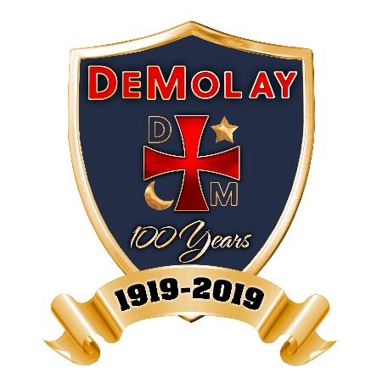
FOR IMMEDIATE RELEASE
(Local Chapter Name) Chapter – City, State
DeMolay International
Contact: Name of Chapter Contact
Address
Phone Number / Email Address

DeMolay International Celebrates its Centennial

In June 2018, DeMolay International entered its centennial year, celebrating 100 years of positive and moral influence for young men in their formative years. Based on the seven cardinal virtues of filial love, reverence, courtesy, comradeship, fidelity, cleanness and patriotism, membership in DeMolay provides a safe, worthwhile program where young men may excel into the successful leaders of the next generation.

Founded in Kansas City, Missouri in 1919, DeMolay International (formerly the DeMolay Council and the Order of DeMolay) enriches the lives of its members by providing a fun-filled program which develops key life skills such as public speaking, budgeting, fundraising, collaboration and event planning. Under the mentorship of certified adult volunteers, every DeMolay member is encouraged to develop at his own pace, making his own unique DeMolay experience.

DeMolay counts among its alumni a multitude of gentlemen who transformed the lessons and examples from their DeMolay experience into the foundation for their success in their personal or professional lives. A select few are enshrined in our International Hall of Fame.

While the DeMolay International centennial celebration will be held in June 2019, these coming months are dedicated to the enhanced promotion of the organization’s tenets and influence as a way to entice a new generation of youth to seek leadership opportunities such as those offered through the DeMolay program.

DeMolay… Tomorrow’s Leaders, Today!

About DeMolay
DeMolay International is a community-based organization for young men, ages 12 to 21. DeMolay members learn life skills, responsibility and cooperation by working together to plan and carry out their customized program of social, sports and community service activities. Adult volunteers act as role models and advisors. Since 1919, DeMolay International has encouraged more than a million young men to become leaders of character, including many successful businessmen, public servants, entertainers and athletes. For more information on DeMolay International, please visit www.demolay.org or www.beademolay.org.
###

