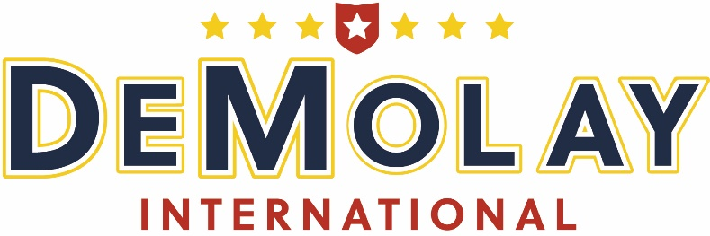
Future Sessions
2020 | June 18-20 | The Arizona Grand Resort & Spa | Phoenix, AZ
- Six unique dining venues on site to satisfy every palate
- Spa, Golf, and Water Park all on site
- Ten minutes from Phoenix Sky Harbor Airport

2021 | June 17-19 | Hilton Anatole | Dallas, TX
- Wednesday Evening Private Event at Medieval Times
- JadeWaters Resort Pool on site
- Ten minutes from Dallas Love Field Airport
- 20 minutes from DFW International Airport
2022 | June 23-25 | Rosen Plaza | Orlando, FL
2023 | June 21-23 | Hilton Cincinnati Netherland Plaza | Cincinnati, OH

